


INSTITUTO POLITÉCNICO
NACIONAL

ESCUELA SUPERIOR DE CÓMPUTO

INSTRUMENTATION
1st Project Delivery

GROUP: 3CV2

Teacher:
ISMAEL CERVANTES DE ANDA

Students:
Adan Cardenas, Andrea Abigail
Bravo Torres, Alejandro
Romero Ortega, Christian

09/09/2019

Project Objectives:
During the first part of the project we confirm the knowledge we got at practice number two, because we used the same circuit but instead of using a thermistor a slide potentiometer was implemented in order to make a distance measuring tool.

Practice Introduction:
A Wheatstone bridge is an electrical circuit used to measure an unknown electrical resistance by balancing two legs of a bridge circuit, one leg of which includes the unknown component.

A slide potentiometer is a kind of potentiometer that changes it’s value as soon as it is slide, as a result it can be used as a distance measure sensor.
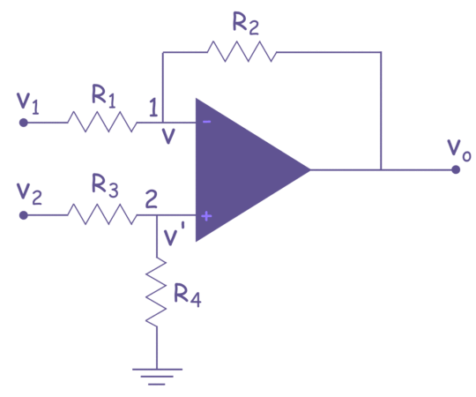
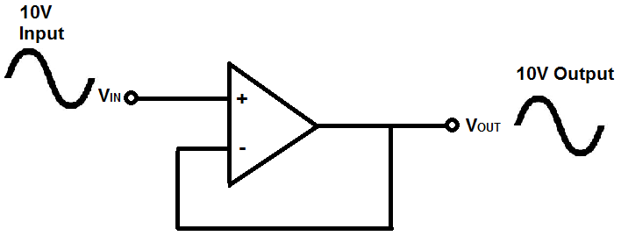
The Voltage subtractor or the subtractor also called a differential amplifier, uses both the inverting and non-inverting inputs to produce an output signal which is the difference between the two input voltages V1 and V2 allowing one signal to be subtracted from another.

A voltage follower (also called a unity-gain amplifier, a buffer amplifier, and an isolation amplifier) is a op-amp circuit which has a voltage gain of 1. This means that the op amp does not provide any amplification to the signal. For example, if 10V goes into the op amp as input, 10V comes out as output.

Voltage Followers are Important in Voltage Divider Circuits
The circuit above works.
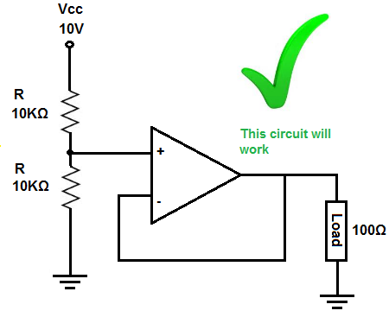
The voltage divider is between the top 10KΩ resistor and the 10KΩ resistor and op amp at the bottom.
The op amp virtually offers infinite input impedance (obviously, it's not infinite in real life). Let's assume it's 100MΩ, though it can be much more.
The equation that would characterize our voltage divider is between, 10KΩ and 10KΩ || 100MΩ.
Doing the math on parallel resistance of the 10KΩ || 100MΩ resistance gives, (10KΩ) (100MΩ)/ (10KΩ + 100MΩ) = 9999Ω ~ 10KΩ.
Any voltage divider composed of the same 2 resistances gives half the voltage of the power supply. But just to show the math, we have the voltage divider formula, 10V * (10KΩ)/ (10KΩ + 10KΩ) = 5V. As we can notice 5 volts falls across the top 10KΩ resistor and 5V falls across the bottom 10KΩ resistor and the 100Ω, because of the 100Ω and 10KΩ resistor are in parallel both receive the same 5V.

Project Development:

At first we needed to build a Wheatstone bridge, but this time instead of using a normal potentiometer or a thermistor a slide potentiometer was used this time, because the main project is to build a distance measurement tool instead of a heat measurement tool.

The slide potentiometer instead of having a washes it allows to change its value by every millimeter it is opened, as a result of this we may have the possibility of measure any small distance in the order of centimeters.

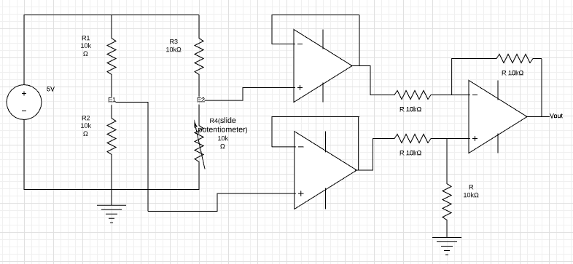

As soon as we finished building the Wheatstone bridge we connected E1 and E2 into a voltage follower. The output from the voltage follower was the input for the subtractor. The result from the subtractor is going to give us information that be calculated in order to know the distance that was supposed to be measured.

Before making the circuit, measure how much is the range of the sliding resistance with the multimeter. First the lever is placed on one end of the distance sensor and the resistance value measured.
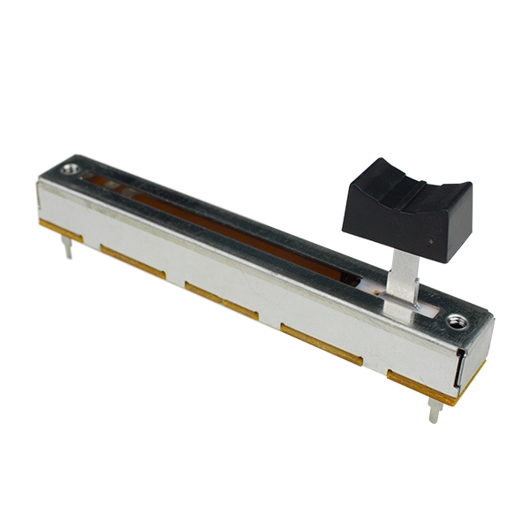
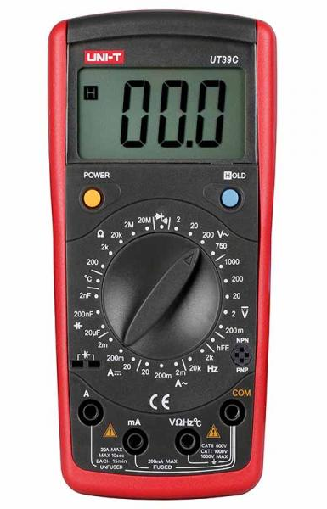

Minimum value of the sliding resistance (Ω) | Maximum value of the sliding resistance (Ω)
0 | 10k

And we perform the calculations for the CAS design

0 Ω to 10kΩ,
0 cm to 6 cm

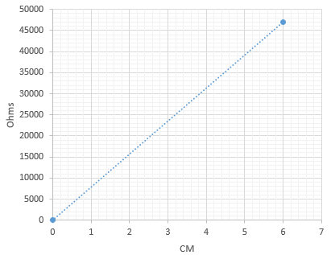

For P1

=
For P2

=

Calculation of the current for the resistance
For

Therefore we choose the value of
and the formule will be:

For
= 0

For 0 cm

= 0

For 6 cm

The subtraction must remain as E1-E2
For 0 cm
E1 – E2 = 2.5v – 0v = 2.5v

For 6 cm
E1 – E2 = 2.5v – 2.5V = 0v

Following the logic of the following formulas, the calculated values will remain as follows

Length (cm) | R_{sen} (Ω) | ΔR(Ω) | E1 (V) | E2 (V) | E1-E2 (V) | V_{SAL} (V)
0 | 0 | 10000 | 2.5 | 0.000 | 2.500 | 2.500
1 | 1666.6667 | 8333.3333 | 2.5 | 0.714 | 1.786 | 1.786
2 | 3333.3334 | 6666.6666 | 2.5 | 1.250 | 1.250 | 1.250
3 | 5000.0001 | 4999.9999 | 2.5 | 1.667 | 0.833 | 0.833
4 | 6666.6668 | 3333.3332 | 2.5 | 2.000 | 0.500 | 0.500
5 | 8333.3335 | 1666.6665 | 2.5 | 2.273 | 0.227 | 0.227
6 | 10000.0002 | 0 | 2.5 | 2.500 | 0.000 | 0.000

Measured Values on the implementation of circuit:

Length (cm) | V_{SAL} (Volts)
0 | 2.216
1 | 2.179
2 | 1.648
3 | 1.147
4 | 1.018
5 | 0.934
6 | 0.733
7 | 0.026

Simulations
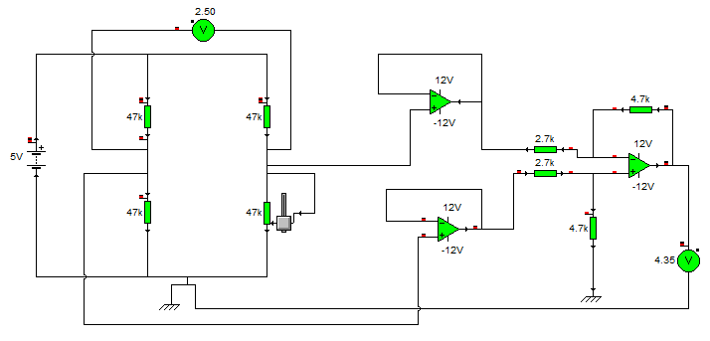

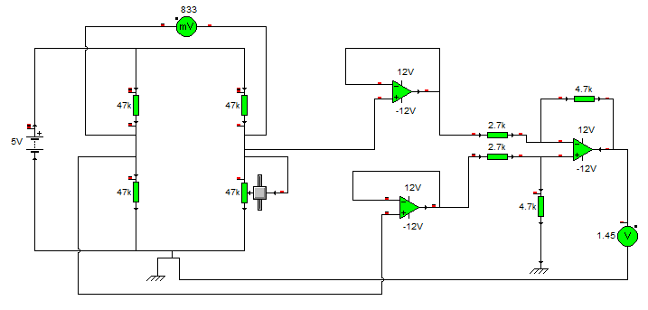

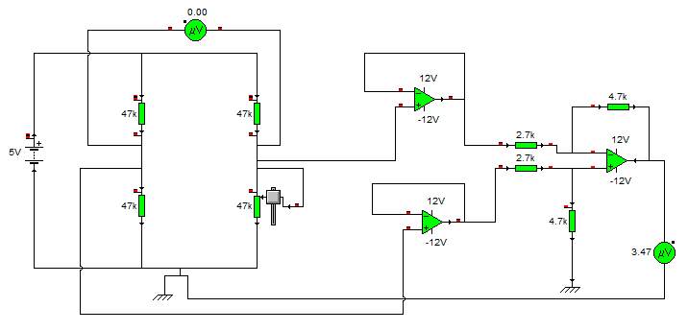

Conclusions
The sensors based on the variation of the electrical resistance of a device are probably the most abundant. This is because there are many physical magnitudes that affect the value of the electrical resistance of a material. Consequently, they offer a valid solution for measurement problems.
During the first part of the project we confirm the knowledge we got at practice number two, because we used the same circuit but instead of using a thermistor a slide potentiometer was implemented in order to make a distance measuring tool.
In this practice we saw the use of the potentiometer as a resistive sensor, the variations of the voltage 2 as a function of the potentiometer were measured, as well as the difference between voltage 1 and voltage 2 and it was compared with the output voltage
With the help of the sliding resistor we observe that it gives us a value in the multimeter and this value changes as we change the value of the resistance and we can use it as a motion sensor.

Bibliography & information Sources
[1] https://en.wikipedia.org/wiki/Wheatstone_bridge
[2] https://en.wikipedia.org/wiki/Potentiometer
[3] https://en.wikipedia.org/wiki/Thermistor
[4] http://www.learningaboutelectronics.com/Articles/Voltage-follower
[5] https://www.allaboutcircuits.com/textbook/semiconductors/chpt-8/building-a-differential-amplifier/
[6] https://www.quora.com/What-will-be-the-CMRR-for-a-differential-amplifier
[7] https://hetpro-store.com/TUTORIALES/amplificador-diferencial/
[8] https://www.academia.edu/29112469/Electrical_Conductivity_and_Resistivity
[9] Ioffe, Abraham F.: Semiconductors thermoelements and thermoelectric cooling. Infosearch Ltd., 1956.
[10] http://www.infoagro.com/instrumentos_medida/doc_termometro.asp?k=62
[11] https://en.wikipedia.org/wiki/Thermocouple
[12] https://es.wikipedia.org/wiki/Detector_de_calor

